Stores_Procedures

--Scenario 1

CREATE OR REPLACE PROCEDURE ProcessMonthlyInterest IS

BEGIN

FOR acc IN (

SELECT AccountID, Balance

FROM Accounts

WHERE AccountType = 'Savings'

) LOOP

UPDATE Accounts

SET Balance = Balance + (acc.Balance * 0.01),

LastModified = SYSDATE

WHERE AccountID = acc.AccountID;

DBMS_OUTPUT.PUT_LINE('Interest added for Account ID: ' || acc.AccountID);

END LOOP;

COMMIT;

END;

/

BEGIN

ProcessMonthlyInterest;

END;

/

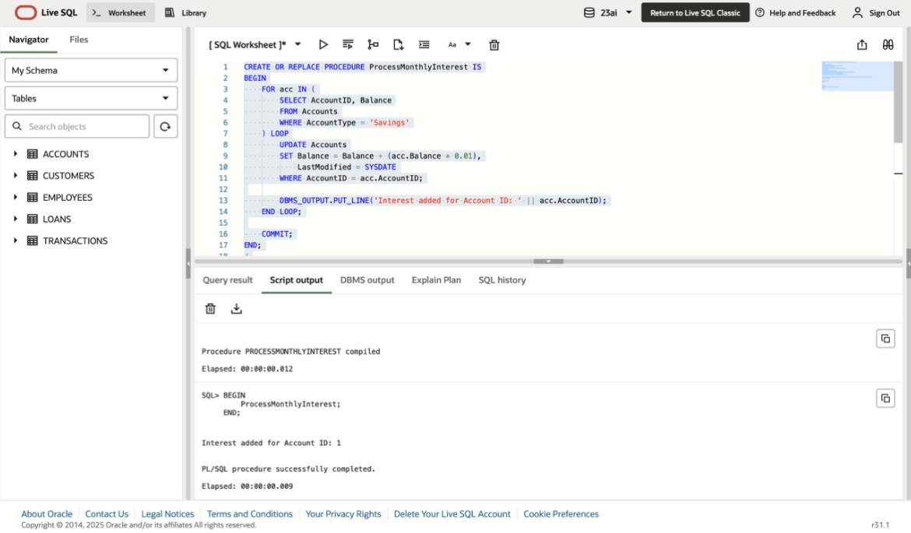

--- Scenario 2

CREATE OR REPLACE PROCEDURE UpdateEmployeeBonus (

p_dept IN VARCHAR2,

p_bonus_percent IN NUMBER

) IS

BEGIN

FOR emp IN (

SELECT EmployeeID, Salary FROM Employees WHERE Department = p_dept

) LOOP

UPDATE Employees

SET Salary = Salary + (emp.Salary * p_bonus_percent / 100)

WHERE EmployeeID = emp.EmployeeID;

DBMS_OUTPUT.PUT_LINE('Bonus applied to Employee ID: ' || emp.EmployeeID);

END LOOP;

COMMIT;

END;

/

BEGIN

UpdateEmployeeBonus('IT', 10);

END;

/



--- Scenario 3

CREATE OR REPLACE PROCEDURE TransferFunds (

p_from_acc IN NUMBER,

p_to_acc IN NUMBER,

p_amt IN NUMBER

) IS

v_bal NUMBER;

BEGIN

-- Check balance

SELECT Balance INTO v_bal FROM Accounts WHERE AccountID = p_from_acc;

IF v_bal < p_amt THEN

RAISE_APPLICATION_ERROR(-20010, 'Insufficient funds in source account.');

END IF;

-- Debit and Credit

UPDATE Accounts SET Balance = Balance - p_amt WHERE AccountID = p_from_acc;

UPDATE Accounts SET Balance = Balance + p_amt WHERE AccountID = p_to_acc;

COMMIT;

DBMS_OUTPUT.PUT_LINE('Transferred ' || p_amt || ' from ' || p_from_acc || ' to ' || p_to_acc);

EXCEPTION

WHEN OTHERS THEN

ROLLBACK;

DBMS_OUTPUT.PUT_LINE('Error: ' || SQLERRM);

END;

/

BEGIN

TransferFunds(2, 3, 500);

END;

/

